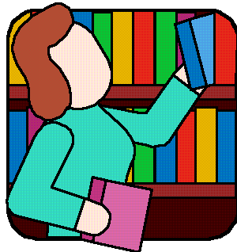Can’t Find Your Library Book?

Here are some places that other kids have looked.

Try some of them!

|  |  |
| --- | --- |
| In Mom's closet  The public library  Grandma's house  House where your babysitter  Dad's house  Mom's house  In your classroom library  In your desk  In your backpack  In your friend's desk  In your friend's backpack  On your teacher's desk  In a toy chest  Under another bed in your house  Behind your bed  In the lost and found  In the after-school program room  On the bus  In the teacher's bookshelves  In the trunk of the car  Under the car seats  Asked the housekeeper  In the recycling bin  At friend's house  At Mom's work  In the trundle bed  Behind the refrigerator  Under the spare tire  Between the mattress and box springs  Under the rug  On top of the dresser  In my locker  At the Public Library | Under the dirty clothes  (or wherever you shove stuff  when Mom says to clean your room)  In the dresser drawers  Behind the chest of drawers  In the garage  In the dog house  Behind the washing machine  In the stroller of the kid you baby-sit  Under the oven  Under the dishwasher  Under the washing machine  Under the dryer  Behind the bookshelf  Behind other books on the shelf  On the VCR (or DVD)  On the TV  On the stereo  In the bathroom  On the back porch  In the refrigerator  In the freezer  At Dad's work  Under the furniture cushions  In the piano bench  Packed with Christmas decorations!  Wedged down the side of a chair  Under the TV stand  In the magazine rack  On top of the refrigerator  Under the couch  On the coffee table  On the floor of your closet |

Based on LM_Net Archives. Robert Eiffert, Librarian at Pacific Middle School.

USED BY PERMISSION OF THE AUTHOR